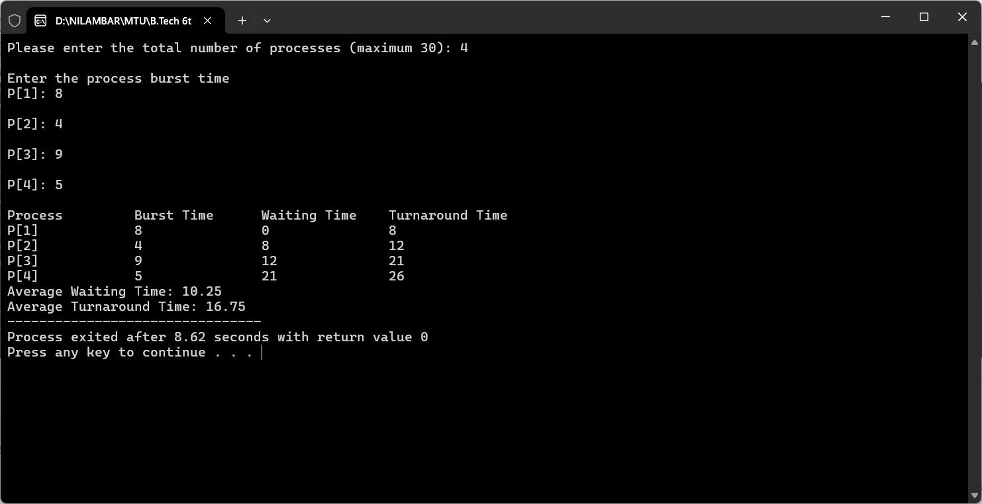

**Experiment 3 Implementation of FCFS using C**